Integrating the Healthcare Enterprise



IHE Patient Care Coordination (PCC)
White Paper

Profiling BPMN for XDW

Revision 0.1 – Public Comment
August 24, 2015
CONTENTS

Closed Issues 3
1 Overview 4
2 Workflow in Healthcare 5
3 An Overview of BPMN 7
3.1 Workflow Participants 8
3.2 Workflow Processes 9
3.3 Creating Tasks 11
3.4 Task Inputs and Outputs 13
3.5 Communicating Between Tasks 13
3.5.1 Message Flows in BPMN 14
3.5.2 Signals in BPMN 14
3.6 States of a Workflow Task 15
3.6.1 Starting a Task 17
3.6.2 Waiting for an Inbound Event 18
3.6.3 Sending an Outbound Event 18
3.6.4 Transitioning to a New State 18
3.6.5 Task State Changes 19
3.6.6 Completing a Workflow 20
4 Common Design Patterns in XDW 21
4.1 Requesting a Service 21
4.2 Scheduling and Dispatching 21
5 Conclusion 22
Appendix A Mapping BPMN to XDW Concepts 23

Closed Issues
- Vocabulary for Notifications:
We can add eventCodes to XDW Updates to record the task being updated, and the state of the task being updated. What should happen if an update does MORE than one task state change? Should multiple event codes be generated? Yes. What about the case where more than one task of the same name exists (if multiple instances of the task can be created)? Simply follow the same rule. If the tasks state changed, report the task and state, and let the Workflow reader figure out whether it was a task of interest.
- Do we need a workflow repository?
Some implementations (e.g., QRPH profile _____) use a workflow repository to get the workflow from. Should this be a configuration time issue, or should it be dynamically load?
This issue has been deferred as a result of transitioning this to a white paper.

Overview
IHE has already defined several workflow definition profiles building on XDW to support several cross enterprise workflows, including:
- Basic eReferral
- Telehome Monitoring
- Tumor Board
- Early Hearing Detection and Intervention
Additional workflows are being developed. However, existing workflows defined in IHE Workflow Definition profiles do not have a common structured representation
The purpose of this white paper is to explore representing an XDW profile in Business Process Model Notation 2.0 (BPMN). BPMN was chosen as the representation format because it is presently the most widely used standard for documenting business processes (workflows), and it has an XML representation that can support documentation of these workflows. While an XDW profile can be represented in BPMN, it may, but need NOT use a BPMN engine to support execution.
The XDW profile enables cross-enterprise workflows to be managed, tracked and executed without central control of the workflow execution. In many kinds of workflow environments, there is no single execution enviroment that supports management of workflows. Instead, XDW workflows are defined in a way that allows their execution by collaborating participants to be facilitated. Each participant has one or more responsibilities for task execution, and coordination is handled through the sharing of a single document that acts as a repository for an instance of the workflow that tracks all workflow activity. By following the rules of execution expressed in the profile, each task in the workflow can be appropriately managed without requiring use of a common workflow execution control agent.
Recent implementor experiences with XDW have demonstated that great value in having a structured format for workflow definition. Such a structured representation supports automation of several important efforts, including:
- Generation of workflow documentation from the structured definition,
- Construction of conformance requirements for workflow participants,
- Development of test tools and simulators,
- Implementation of and integration with workflow participants.

Workflow in Healthcare
Figure 2-1 below depicts one structure by which a disease specific care management program might be implemented.
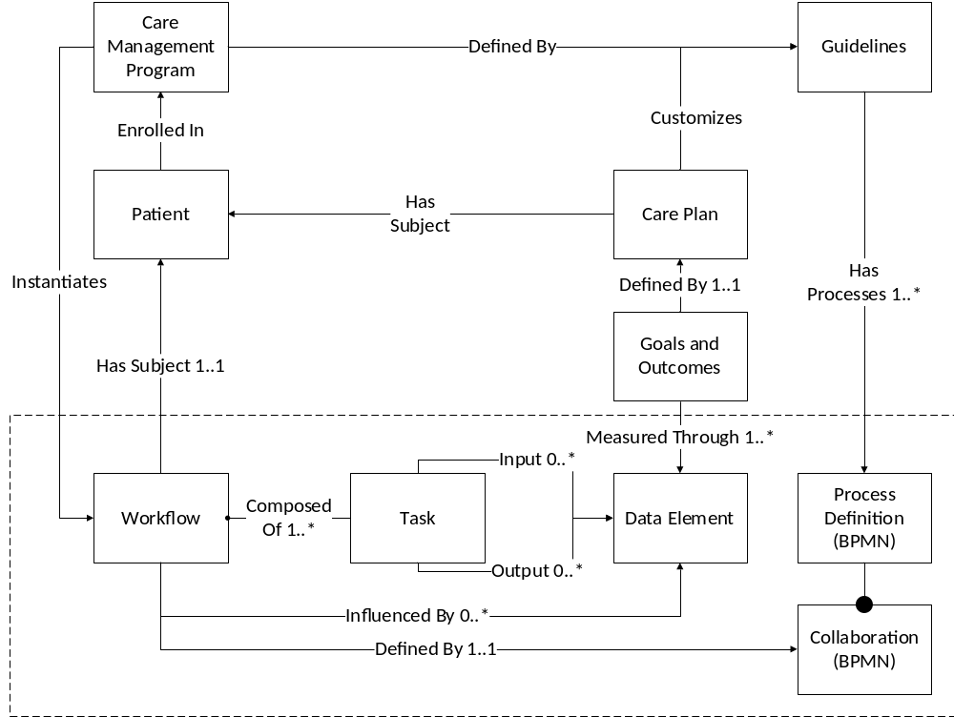
Figure 2-1 A Workflow for Care Management
The care management program enrolls a number of patients. The program is defined in terms of guidelines specific to the disease being treated for these patients. Each patient may be associated with a care plan, which essentially customizes the guidelines to each patient’s disease based on various parameters, including demographics, disease state, et cetera. The care plan can be updated as the patient progresses through various stages of treatment and management.
The care management program instantiates one or more workflows for the patient based on their current state. These workflows comprise several tasks which must be performed. The workflow is defined by a BPMN collaboration (a workflow definition), which is composed of multiple process definitions. Each process defines the activities associated with a task (not shown in the diagram), the inputs and outputs and decision logic associated with the task.
Inputs allow tasks to consume, and outputs are where tasks produce data elements. These may be documents, or components found in documents. The care plan or guideline associates goals and outomes with various data elements. The goals and outcomes can be used to measure how well the care management program is doing with respect to an individual patient or a population.
Some workflows are episodic. They are triggered by a specific event, which is often associated with the existence of a data element, or its absence. The workflow proceeds through a number of steps until it completes, usually under the assumption of a positive outcome, with exceptional negative cases.
Other workflows are continuous while the patient is in a specific state. In these cases, there are periodic activities which are performed repeatedly until the patient leaves that state. Departure of a patient from a particular state often is related and indicative of disease progress, which can be positive (cure, remission or better control) or negative (disease progression or patient death).

An Overview of BPMN
Business Process Model Notation 2.0 (BPMN) is the most recent standard developed by the Object Management Group to support exchange of Business Process documentation. BPMN is supported by a wide variety of business process documentation development tools for documenting business processes, and by workflow and business process engines to support execution of those workflows. The notation supports several different diagrams to document a workflow.
For this overview, we will build a BPMN diagram for the Cross Enterprise Basic eReferral profile developed by IHE PCC. This was one of the first XDW profiles developed in IHE. The examples are based upon, and will extend capabilities in XBeR to show how BPMN can make information more comprehensible, easier to implement, and more robust.
The collaboration diagram in BPMN represents a complete XDW workflow definition. The diagram provides an overview of a workflow, organizing it in vertical or horizontal rows called pools as shown in the figure below. This collaboration diagram reflects the workflow participants of the XBeR profile. The workflow participants in the XBeR profile are shown in the table below.
Table 3-1 XBeR Workflow Participants
Workflow Participants | Description
Referral Requester | Health Professional (e.g., GP) that initiates the referral workflow. Produces the eReferral and the related supporting document.
Referral Scheduler | Participant responsible for the scheduling of the referral, by providing an appointment for the patient
Referral Performer | Participant responsible for execution of the visit. This workflow participant encapsulate many entities within the enterprise that responds to the referral request and produce the clinical report of the visit ending the eReferral process
Workflow Monitor | Participant that tracks progress of the workflow and reacts to certain exception conditions. This participant can be standalone or grouped with one of the above Workflow Participants
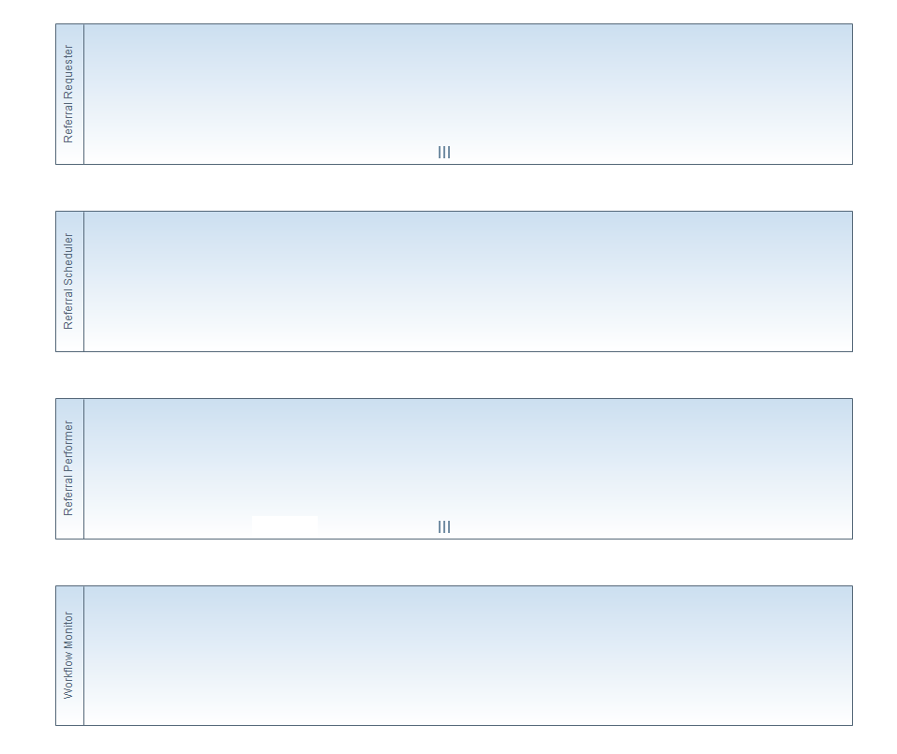
Figure 3-2 Pools in BPMN
Each pool represents the activies of different participants in the business process. The pools are labeled with the name or description of the participant. These pools represent workflow participants in an XDW Workflow. When there can be multiple participants playing the same participant role, the pool is marked with three vertical bars ||| at the bottom, as shown in the diagram above for the Referral Performer. In BPMN, this symbol appears in a workflow when the cardinality of a workflow participant is greater than one. BPMN does not have way to encode “unlimited” in a collaboration diagram for the number of workflow participants of a particular type. For XDW workflows, we have established the convention that when the maximum cardinality of a workflow participant is 10, this means “unlimited”. Smaller numbers represent an actual cardinality of participants.
Each pool can be further divided into swimlanes. In BPMN 1.0, these represented different roles undertaken by the participant. In BPMN 2.0 they can be used for the same purpose, but their use has been broadened to support any classification associated with workflow activity that may need to be depicted in a workflow model (e.g., user activities vs. system activities).
Swimlanes may be used to document other IHE actors grouped with a participant, showing the tasks these IHE actors perform within the workflow. Each workflow participant is already assumed to be grouped with IHE Document sharing and Secure Node actors. The activities of these actors need not be explicitely described within the collaboration diagram, as the behaviors are specified in the XDW profile itself.

Workflow Participants
Some workflow participants have common behaviors, and should be named to reflect these behaviors. Workflows are typically initiated by a requestor, scheduled or dispatched by another participant, and then performed by yet another. XDW profiles often define special participants; a workflow monitor that tracks progress, operating essential in read-only mode on workflows, and a workfow manager that can alter the workflow process. The Workflow Monitor supports the implementation of a workflow dashboard, notifications and escalations, but typically does not alter the state of workflow instances. The Workflow Manager participant has the same capabilities as the Workflow Monitor, but is also able to change the state of the workflow (e.g., reassign a task to another participant, cancel a workflow or task, et cetera), or make other changes. At present, few XDW workflow profiles assign specific tasks to these actors, but they are often essential actors in the information system environment to provide support for the workflows. These behaviors and naming conventions are described in the table below.

Name | Behavior
Activity Requestor | An Activity Requester is making a request to have some activity performed (a referral, a study, a read of an image). Activity describes what is being requested (e.g., Referral, Remote Read), and should be replaced with the activity being described by the workflow definition. There are typically multiple activity requesters in a workflow network.
Activity Scheduler | An Activity Scheduler is scheduling Activity to be performed by one or more Activity Performers. It may be responsible for selecting the Performer, or negotiating with multiple performers to seek an available or willing performer to complete tasks in the workflow.The distinction between the scheduler and the dispatcher is that the scheduler makes a plan regarding when the task will be performed. There is typically a single scheduler managing the schedules for multiple performers in a network. The scheduler may be singular in the network, or the network may be subdivided into regions or separate collaboration networks. If multiple schedulers are permitted within a workflow, this participant should be marked with the ||| symbol to indicate that multiple schedulers are permitted.
Activity Dispatcher | An Activity Dispatcher is responsible for identifying one or more Activity Performers to dispatch a task to. It may select the Performer based on some logic, or negotiate with multiple performers. A dispatcher is like a scheduler except that it does not establish any specific time for performance, only assignment of performer. Like the scheduler, there can be a single dispatcher, or dispatchers may cover a specific region, or multiple dispatchers may somehow collaborate to federate the dispatching capability.
Activity Performer | The Activity Performer performs the task being requested by the Activity Requester. It often communicates back to the original requester when the activity has been completed, providing the results of its process. There are typically multiple performers in a workflow network.
Workflow Monitor | The Workflow Monitor is able to read the state of current workflows and access notifications. It is typically used to provide dashboarding capabilities, and simple escalations (e.g., e-mailing a user when a task is overdue).
Workflow Manager | A Workflow Manager is able to read and alter the state of current workflows. In addition to dashboarding, it supports other management activities associated with workflows. These may include escalation activities, reassignment to address congestion or network issues, et cetera. A workflow manager may be directed by a human, may be automated, or a combination of both.

Workflow Processes
The content of a pool describes the process performed by a workflow participant. This is the collection of tasks associated with the XDW workflow participant. An example is shown in Figure 3-3 below for the Referral Scheduler of XBeR.
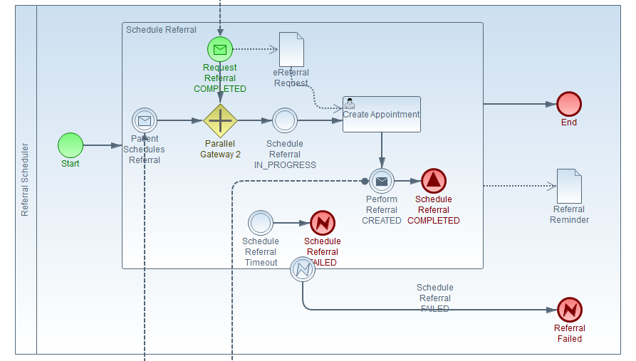
Figure 3-3 A Workflow Participant’s Business Process
The symbols shown in Figure 3-3 are further described in Table 3-2 below. Other symbols are also used in BPMN, allowing further process complexity to be depicted.
Table 3-2 Basic Process Notations
Symbol | Description
 | The process begins at the start symbol. A process (or sub-process) can contain only one start symbol. A start symbol can contain an icon to represent the kind of trigger event that caused the process to start (e.g., reciept of a message, an event).
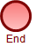 | The process is complete when it reachs an end symbol. A process (or sub-process) can contain multiple end symbols. Each end symbol can represent a different final stage in the process, depending on the process flow.
 | Tasks that are executed during the process are represented in rounded rectangular boxes. The boxes are labeled with the task name. Tasks can contain icons representing the kinds of tasks being performed (e.g., TBD), and which indicate particular features of the task (e.g., ).  A sub-process is a special kind of task which may contain a + symbol at the bottom. This sub-process can be expanded to depict the internal process it represents.
 | The process flows in a sequence, described by solid lines with arrows showing the order in which the tasks are performed. Sequences depicted in BPMN do not cross pool boundaries.
 | Diverging and converging branch points within the process are represented in diamond shapes. The symbol within the diamond indicates the type of branch point. A + symbol inside the diamond is a parallel branching point. The process follows all the sequence lines exiting this shape in a diverging branch point (where multiple arrows leave the branch). In a converging branch point (where multiple sequences enter the branch point) the process continues once all sequences reach the branch point, representing a parallel join in the process.
A diamond containing a × symbol (or no symbol) represents an exclusive branch point. A diverging branch point represents a decision point in the process. Only one sequence exiting the branch point is executed, based on the condition expressed in the branch. Usually this kind of branch point is labeled with the decision, and the sequence arrows represent the varying conditions which must exist to be followed.
In a converging exclusive branch point, the process continues when the first sequence reaches the branch point.
 | Data items represent task inputs and outputs, and these are shown as document shapes. When annotated with parallel bars, the shape describes a collection, rather than a single item.
 | Inputs and outputs are connected to tasks with dotted lines. The direction of the arrow indicates whether the item is an input or an output. The output of one task may be used as the input to another. This can be represented by connecting the data item to a sequence flow using the dotted line.
 | Communications across process boundaries are described as messages, represented as an envelope.
 | Messages are connected between process pools or tasks within process pools by dashed lines, with arrows representing the direction of the message flow.

Creating Tasks
An XDW task can be a simple interaction, or comprised of steps that include several interactions with users and other system actors, and may possibly have different sequence flows based on data or other events. A simple interaction where the task starts, is performed, and then completes is represented with a BPMN task icon.
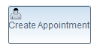
Figure 3-4 A Simple Task
A more complex XDW task that has conditional flows or multiple steps (including state changes) can be represented using a BPMN subprocess as shown in Figure 3-5 below. Many BPMN modelling tools do not provide sufficient space to represent the complex flow within a subprocess and still make the collaboration diagram easy to interpret. We recommend that the collaboration diagram simply provide an overview of the entire process, but not go into the detail of each task within the overview collaboration diagram. Additional detail should be specified in BPMN process diagrams.
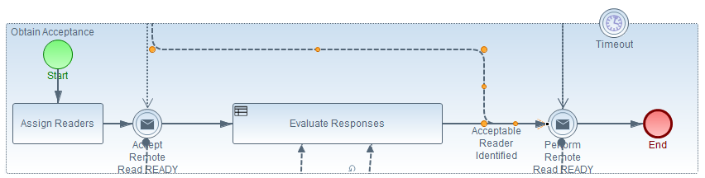
Figure 3-5 A Complex Task with Multiple Steps
For the XBeR profile, there are three tasks, one for each of the participants. Each workflow participant starts, performs its single task, and then finishes. The start event, workflow task and end event are connected with arrows in the sequence that these events or activities occur. The name of the task reflects the name of the XDW Workflow task.
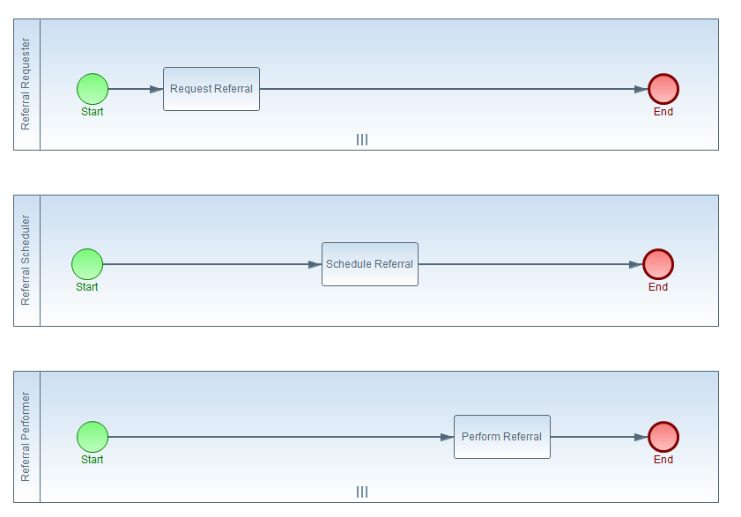
Figure 3-6 Adding Workflow Tasks

Task Inputs and Outputs
Each XDW task can have associated inputs and outputs. These are documents. Inputs are used by a task. Outputs are produced as a result of completing steps within a task. Usually the intent of an XDW Workflow is the production of a final document or set of documents which describes the services provided during the execution of the workflow. In BPMN, tasks have input and output data items. These are connected to tasks using data associations. These data items represent the XDW input and output documents.
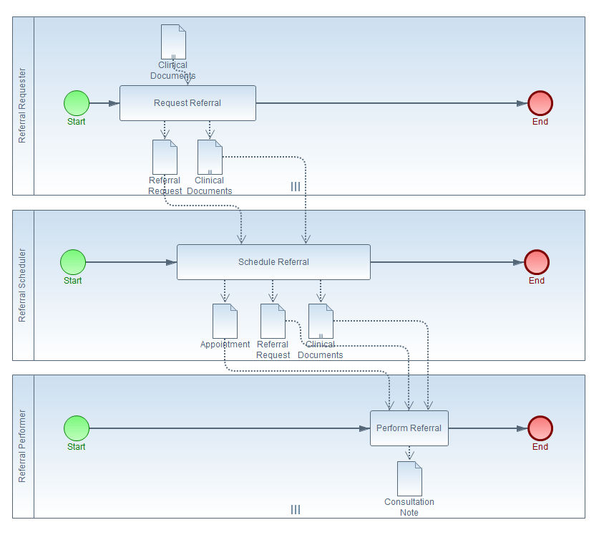
Figure 3-7 Adding Inputs and Outputs

Communicating Between Tasks
Communications between processes in different pools in BPMN is done through messages or signals. Messages are targeted communications between different entities, where the sender targets a specific reciever. Signals are not targeted at an individual entity, and can be accessed by any process in any pool. We have established the convention that XDW state changes that are principally used to synchronize activity between two workflow participants should be represented as messages in BPMN. However, state changes which are recorded and used to synchronize more than two participants be represented as signals.
In BPMN, a message is a communication that occurs between two different workflow participants. Messages are not sent between tasks inside a single workflow participant because these tasks are part of the same process, and presumably can communicate readily without having to send a message. Messages are described in BPMN through Message Flows. The message flows describes communications between two distinct participants, and help in sequencing the workflow. Messages are only used to communicate between two participants in BPMN. To comminicate across more than two participants, see the discussion on signals below.

Message Flows in BPMN
The sequence arrows in the previous diagram illustrate the order in which tasks are performed by a workflow participant. However, it does not show the communication between tasks across participants and the ordering of those tasks. The next step is to add these communications to the workflow collaboration diagram. This is done in BPMN using Message Flows as shown in the figure below.
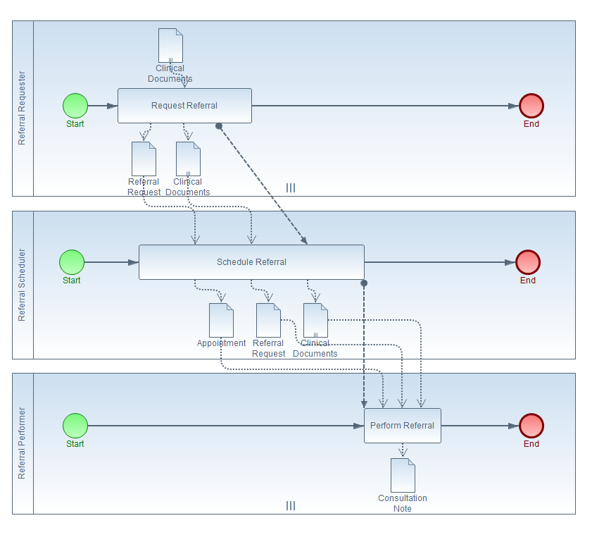
Figure 3-8 Adding Message Flows
Message flows indicate points in time at which the state of the workflow is communicated between tasks. In XDW, this most often occurs when a state change has occurred in one or more tasks in the workflow. For example, when the Request Referral Task above has reached the COMPLETED stage, the XDW Workflow Document is updated with outputs created by that task, and the task itself is marked as being completed. That change indicates that the Schedule Referral task is ready to start.

Signals in BPMN
Signals in BPMN represent events which are broadcast to anyone who is interested and follow a publication/subscribe implementation model. Signals are used to communicate with more than two particpants in BPMN. The closest analogue to a signal within IHE profiles is found in the IHE DSUB Profile. In that profile, the ITI-54 Document Metadata Publication transaction acts as the signal.
In the XDW environment, we have assumed that these IHE DSUB messages will be used to support task synchronization. We also suggest that the publication of DSUB messages be coordinated by the workflow monitor, rather than requiring each workflow participant subscribe to, or generate notifications of activity as necessary. This suggests that a new profile describe this behavior of the workflow monitor and workflow participants.
DSUB allows actors to subscribe for document update messages for a given patient, and a change proposal that has been suggested is to allow participants to also subscribe for messages associated with a particular event or identifier. This enables the workflow monitor to have defined behavior when an XDW document is changed. The defined behavior allows the workflow monitor to send notification messages to workflow participants based on several key factors:
- The type of workflow participant (e.g., Referral Requester, Referral Scheduler, Referral Performer).
- The task being updated within an XDW submission set.
- The state change performed to that task in the XDW submission set.
- The messages caught by a participant during its processing.
- The creator, owner, and notification list associated with a task.
When an XDW workflow definition in BPMN indicates that a workflow participant can catch a state change message or signal, it would be automatically “subscribed” to that signal for tasks owned by that workflow participant. When a XDW workflow participant creates a task, it must identify itself as the task creator in the XDW document. When that task is assigned or reassigned to a workflow participant, or the workflow participant takes ownership of that task (e.g., from a list of CREATED tasks that have not been assigned), the XDW Task must identify that workflow participant as the owner of the task.
In some cases, such as the Referral Scheduler above, the originator of an activity (the Referral Requester) may not initially be aware of which workflow participant is later be assigned to that activity (e.g., the Referral Performer). To ensure that notifications can be properly routed, the creator of a task must add interested workflow participants to the notification list for a task. Thus, in the example above, when the Referral Scheduler creates the Perform Referral task for the Referral Performer:
- The Referral Scheduler added as the task creator.
- The Referral Performer added as the task owner.
- The Referral Requester is added to the notification list for the task.
When a workflow monitor detects an update to an XDW task, it notifies the task creator, the task owner, and any workflow participant on the notification list for the task of the state change.

States of a Workflow Task
Tasks in XDW typically have one of five states: Created, Ready, In Progress, Failed or Completed. An XDW workflow task can migrate through several of these states. IHE Workflow definitions require tasks to be recorded in the workflow document when they reach certain states, but other states may also occur and can be recorded (they simply aren’t documented in the profile, which doesn’t mean that they cannot be used).
In some cases, a state change is recognized in the profile as being one which may be useful but not required to be documented, and so it can optionally be recorded. In these cases, the IHE Workflow Definition might also include other requirements about what must be documented when the task reaches that state (e.g., input or output documents available at that time). Some of these states are listed in the table below.
Table 3-3 Task States
Task States | Description
CREATED | The task is created but not assigned to an owner
RESERVED | The task is created and assigned to an owner but not yet ready to be performed.
READY | The task created is assigned to an owner and is ready to be performed
IN_PROGRESS | The task is started and the owner is performing the task actions
FAILED | The task is completed with fault response (it is not possible conclude the action of the task)
COMPLETED | The task is completed with response
The RESERVED state listed above is not referenced in the XDW profile, but but may be used as XDW allows any state in WS-Human Task to be used.
An XDW Task need not transition through every state listed above. The state transition diagram below shows the most common transitions between states. Note that in XDW, a task may be first recorded as having reached the COMPLETED state without any record of having reached any preceding states. Tasks can also transition “backwards”; for example, reverting from the IN_PROGRESS state to the READY state.
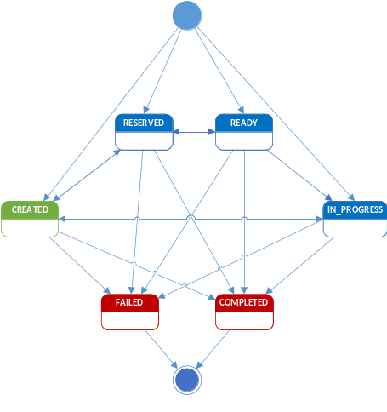
Figure 3-9 XDW State Transitions
Documenting state transitions in a BPMN diagram is done by adding a BPMN event to a process or sub-process. You have already seen the use of start events and end events in the preceding section. BPMN also supports other types of events. Intermediate events occur within a task to indicate that the task either generates an event (an intermediate throw event), or catches an event (an intermediate catch event). Intermediate events appear as a double circle in BPMN.
Border events on subprocesses catch an event generated within the subprocess (or any of its subprocesses), supporting transitions to other activities outside of that process. Border events appear on the border of a subprocess. A border event can interrupt a subprocess, or allow it to continue without interruption but initiate other activities. Non-interrupting border events are useful to initiate escalation activities such as notifying an administrator or task performer that a task has missed a deadline. Interrupting border events are often used to support error handling. The figure below shows a subprocess with a number of different kinds of events.
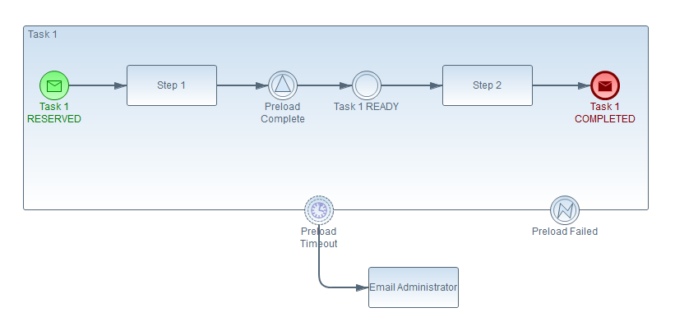
Figure 3-10 Using Events in a Subprocess
Within the subprocess in the figure, you will note that the start and end event have an envelop icon inside them. That indicates that a message is associated with the event. Icons that are not filled represent incoming events (e.g., received messages or caught signals). Icons that are filled represent outgoing events (e.g., sent messages or thrown signals). Border events always catch events that are generated (thrown) within a subprocess or its subprocesses. Interupting border events have a solid outline. Non-interupting events have a dashed outline and represent a paralell sequence flow.

Starting a Task
A variety of different events have been used in different XDW profiles to handle sequencing of tasks across XDW workflow participants. A task is usually started when another task completes or reaches a particular state, but can also be explicitely created in a particular state by another task. This leads to complex implementations because the rules are often not explicitely stated in the XDW workflow definition.
BPMN provides a way to be more explicit about the events that initiate a task. We have established the convention that the start event of a task will explicitely indicate the event that initiates it. This may be the transition of another task into a new state, or the creation of the specified workflow task in a particular state.
In the example above, Task 1 is initiated when some other workflow task creates it in the RESERVED state. It could also have been initiated when another workflow task reached a particular state. For example, if Task 1 needs to start when the Request Referral task reached the COMPLETED state, it would have been named “Request Referral COMPLETED”.

Waiting for an Inbound Event
Within a workflow task, often the workflow participant of the task must wait for something to occur. In the example above, Task 1 will not be READY for someone to work on it until inputs to the task have been transferred to a local system. This is often the case when DICOM studies must be transferred from one system (e.g., a central repository) to another (e.g., a local PACS or workstation). Since preloading can involve megabytes or gigabytes of data, this requires that the reading of the image wait upon the image to be transferred to the local system. Step 1 in the example above initiates the DICOM transfer. Then the task waits until the transfer completes. When the transfer completes, the system performing the transfer generates a signal labeled “Preload Complete”. When this signal is caught by Task 1, it is ready to move on to the next step.
The types of inbound events that can be caught within a task include signals (which use a triangle icon), messages (which use an envelope), and timers (which use a clock). Boundary events can catch all these and also catch error events (which uses a lighting bolt). Events can also have an unspecified type with no icon. Start events are always inbound. Inbound events can also be of an unspecified type.

Sending an Outbound Event
The types of outbound events include messages, timers, signals, unspecified, and errors. The first four can be sent by intermediate events. The End Event can send all of these and are always outbound events. The Task 1 READY event in the example above is an outbound event that is of an unspecified type. This is used to document a state transition.

Transitioning to a New State
As steps are completed in an XDW task, the task can transition from one state to another. Indicating these state transitions in the workflow is not always essential, however, it can be beneficial. The workflow monitor actor described earlier in this document can use state transition information to identify bottlenecks within a workflow so that these can be addressed by direct intervention or process improvements. Thus, we recommend that workflow state transitions be documented within an XDW workflow definition. These state transitions need not be stored in the XDW Task unless they are necessary to initiate or synchronize other activities within the XDW workflow.
To specify a state change of the task, create an intermediate throw event in the BPMN diagram. The name of the event will be the task name, followed by the name of the new state. A task is created when its start event occurs, and it begins in the CREATED state, so there is no need to explicitly label the start event of a task unless it differs from this default. Tasks state changes are usually initiated by the task whose state is changing in XDW, but can can also be updated by other tasks.
To specify that a task must wait until its state is changed by external activity, create a new intermediate catch event in the BPMN diagram. Label the event with the task name and the state being waited upon. The same process is used to specify that a task must wait until another task reaches a specified state.
XDW profiles specify when a workflow participant must update the XDW workflow with state changes, and when state changes may optionally be updated. In the example given above, Task 1 has an unspecified event definition (it has no icon inside it). This indicates that the workflow participant MAY record a state change for Task 1 in the XDW Workflow Document to indicate that this task is ready. Workflow participants should perform these updates because it improves the information available for process improveent, but are not required to do so.
If a state change must be recorded according to the XDW workflow definition, the event must be either a message or a signal, as unspecified events indicate cases where state change updates may but need not be recorded.

Task State Changes
Within the task whose state change is represented by an event:
- When the state change is used in a start event, the signal event is an unfilled envelope or triangle (representing a message or signal) in the catching state. A task cannot “throw” its own start state change event.
- When the state change is used in an end event, the signal event is a filled envelope or triangle (representing a message or signal) in the throwing state. A task cannot “catch” its own completion state change event.
- When the state change is used in an intermediate event, the signal event represented by a filled envelope or triangle representing the throwing state indicates that the subprocess has changed its own state to the new state.
- When used in an intermediate event, the signal event represented by an unfilled envelope or triangle representing the catching state. This indicates that the subprocess waits until its state is changed to the specified state (by some other task or activity).
Other workflow tasks can also catch or throw state change events for tasks other than themselves. When catching, it means that this task waits until the state change event occurs before continuing. From a BPMN perspective, the token generated by this event isn’t released into the sequence flow until the event occurs. When throwing, it means that this task records the state change for the affected task in the XDW document.
When a task fails, this is represented by the error event. Within the task, the filled (throwing) error icon appears within the end state to indicate a sequence that ends in failure. Outside of the named task, the unfilled (catching) error icon can be used to represent cases where the catching task can take action should the named task fail.

Completing a Workflow
Workflows can complete synchronously or asynchronously. When a workflow is finished, participants that are waiting for an event to occur need to be notified so that they can stop any processing on behalf of the workflow.
In addition, wrkflows may not finish normally, either because the request was cancelled by the originator, or aborted or failed during processing in ways that do not allow it to complete normally. When a workflow cannot or should not be completed normally, all participants than may be actively processing tasks for this workflow should be notified.
To satisfy these requirement, we create two new events which represent a workflow reaching a terminal state. These are the Workflow COMPLETED and Workflow FAILED events. The name of the event is the name of the workflow, followed by the state of the workflow (COMPLETED or FAILED). These are always caught or thrown as signals, since they communicate to all workflow participants.

Common Design Patterns in XDW
XBeR develops a common interaction pattern in XDW workflow profiles, requesting a diagnostic, treatment or other service (e.g., remote monitoring setup and configuration). Often a centralized scheduler or dispatcher is needed to coordinate this request among multiple possible performers.
A BPMN workflow implementing the tasks defined for XBeR is shown below in Figure 4-11. Note that this workflow does not exactly follow the workflow defined in XBeR due to the application of best practices described herein.
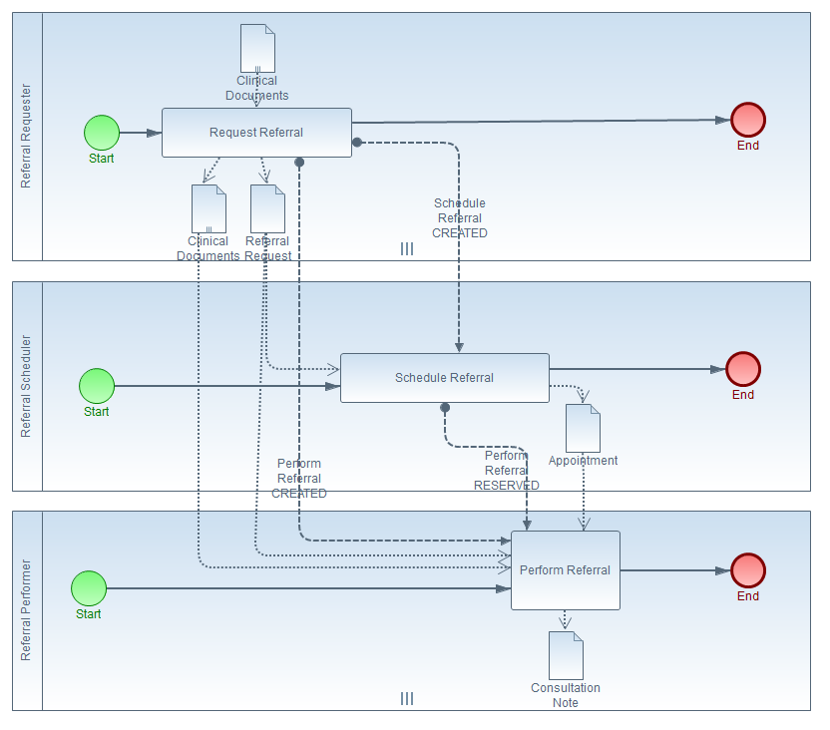
Figure 4-11 XBeR Workflow

Requesting a Service
Requesting a service involves several steps:
- Creation of a document describing the service or service(s) to be performed (see the Referral Request Document in Figure 4-11).
- Selection of other appropriate documents (see Clinical Documents in Figure 4-11) that may be used during the performance of the service (e.g., clinical information, images, lab results).
- Creating the task to be performed and associating those inputs with it (see the Perform Referral CREATED Message Flow).
- Requesting the service be dispatched or scheduled by a centralized service (see the Schedule Referral CREATED Message Flow).
The step 3 has typically been assigned to the scheduler/dispatcher participant in existing IHE workflows. However, it should be performed at the time the service is requested. Creation of the task at this point allows:
- Tasks to be adopted by performers without intervention by a scheduler/dispatcher when the task assignment strategy is “first available performer.”
- Easier computation of metrics on the service task (e.g., task creation to ready to in_process state change times).
- Direct assignment of inputs needed for the performing task, rather than using pass-through inputs and outputs in the scheduling/dispatching task (note assignment of Clinical Documents to the Perform Referral Task rather than passing them through the Schedule Referral Task).
- The task performer to identify the original requester without extra steps (the task creator is the requester), and facilitates exchange of notifications.
There may be reasons for not having the service requester perform the task. These include cases where the type of task to be performed depends upon the type of service requested, and where these details are hidden from the task requester.

Scheduling and Dispatching
The difference between scheduling and dispatching relates to the assignment of a slot or scheduled time for performing the task. Otherwise the two activities have a great deal in common. A more detailed example for the XBeR profile is shown in the BPMN process diagram in the figure below.
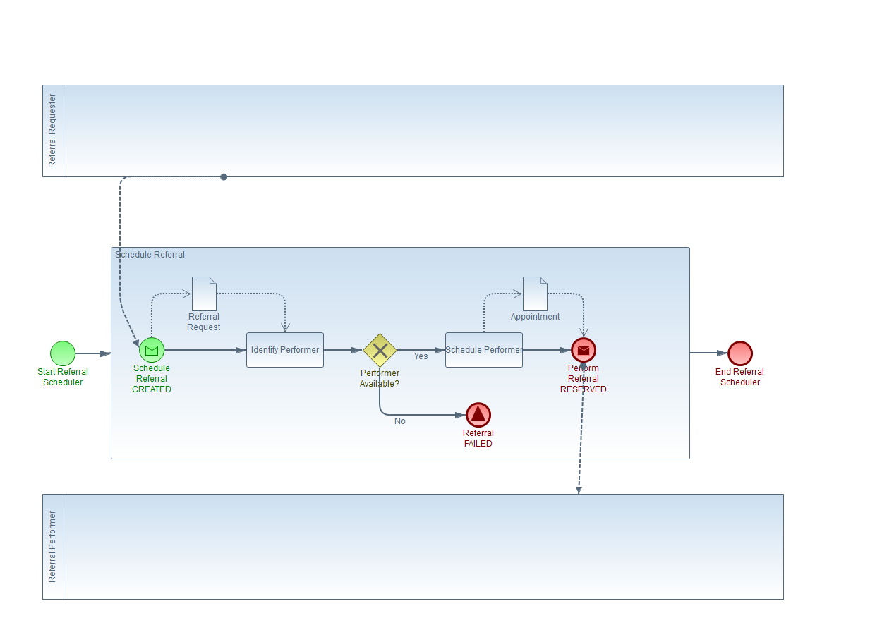
Figure 4-12 Scheduling Process
Steps involved in scheduling or dispatching include:
- Identification of task performers that can do the work (See Identify Performer Task in Figure 4-12).
- Negotiation of task acceptance/schedule, possibly with input from the task performer(s) (see Schedule Performer Task in Figure 4-12).
- Assignment of the task performer(s) (see the Perform Referral RESERVED Message Flow in Figure 4-12).
With scheduling, one of the outputs should be documentation of the scheduled service. We recommend use of the iCal format (RFC 5545) to record the scheduled appointment in a document (see the Appointment output data item in Figure 4-12).
As the figure above illustrates, should a situation occur that prevents completion of the workflow, this is identified and communicated via a signal.

Conclusion
This whitepaper has illustrated how common workflow profiling activities can be represented in BPMN 2.0, and has established some guidelines and best practices for implementing an XDW profile in BPMN. It has also demonstrated common patterns that have already been established in multiple IHE workflow profiles.
These guidelines, best practices and common patterns would greatly benefit from the development of an IHE specification documenting the way a workflow is described using BPMN 2.0. We would recommend development of such a specification in future IHE development cycles.
We also encourage new XDW profiles to use BPMN and the best practices described above in this document. Use of BPMN will describe the workflow profiless in ways that are already well understood and using common industry practices to describe workflows. The best practices will bring greater consistency to XDW profiles, making them easier for implementors of these profiles to understand. They will also provide more capable implementation, and better error handling in the profiles.
Appendix A Mapping BPMN to XDW Concepts
BMPN and XDW concepts are mapped to each other in the following table.
XDW Concept | BPMN Concept | Comments
Workflow | Collaboration | A BPMN collaboration diagram represents the workflow followed by a number of participants in a business process.
Workflow Particpant | Participant | The BPMN participant and the XDW Workflow participant represent the entities that are collaborating. In BPMN these entities can be organizations, groups, individuals or systems. In XDW, these entities are profile actors representing systems acting on behalf of organizations, groups or individual users.
Workflow Task | Sub-Process | In BPMN, units of work are described as activities, usually represented as tasks and sub-processes. XDW represents these as workflow tasks.
Collection of Workflow Tasks assigned to a Workflow Participant | Process | A process in BPMN is associated with a single type of workflow participant shown in a pool. This represents constraints on the collection of tasks being performed by a workflow participant in an XDW Workflow profile.
Sequence of activities followed within a specific workflow task. | Sub-Process | A sub-process in BPMN can be used to describe the activities performed by a single type of participant to complete a unit of work. In XDW this represents specific steps in an XDW task, e.g., creating and publishing documents and updating the task status in the XDW Workflow Instance.
State Change | Event | State changes in an XDW workflow are represented by BPMN Events.
Workflow Activity | Activity | A step in a workflow task.
Submission Set | Message | Messages in BPMN represent directed communications between participants. Messages can be sent or received by specific tasks within the process, or just be associated with a process. A BPMN message can have an associated message endpoint.  XDW shares content using transactions from IHE profiles (e.g., XDS, XDR or XCA) to support communication between tasks and processes. Within XDW, the submission set is communicated via these transactions (e.g., Provide and Register Document Set), and individual workflow participants are expected to access the information content using related transactions (e.g., Query Documents, Retrieve Document Set).
DSUB Notification | Signal | Signals in BPMN represent communications that are not directed to any specific recipient. The IHE DSUB profile supports notification based on transactions associated with document sharing (e.g., XDS, XDR or XCA).
Document | Data Item | Data in BPMN is communicated through data items. In BPMN a data item can be associated with an XML Schema to describe it. In XDW, data items are communicated using documents, and it is described using document sharing metadata.
Input Document | Data Input | Data items can be used as inputs to activities in BPMN. These are represented as input documents in XDW.
Output Document | Data Output | Data items can be used as outputs from activities in BPMN. These are represented as output documents in XDW.

This document can be found at http://www.ihe.net/uploadedFiles/Documents/PCC/IHE_PCC_Suppl_XBeR-WD.pdf

